**Name - Parmeshwar\***

**Assessment ( Git & Jenkins)**

**Problem Statement: Automated Deployment of Web application**

**Q1) Design and develop tasks required to build CI CD pipeline using learned technologies to deploy Web application to cloud platform as a set of microservices on containerized platform such as docker.**

**Just to summarize, Fetch the Source code from GitHub as Version Control Web Based Platform & Pull in Jenkins to create a build using script and deploy on a containerization platform. Containerization platform which packages the application and all its dependencies together in the form of Container to ensure that the application works seamlessly in any environment.**

**Step 1) Created nodes and Connected successfully.**

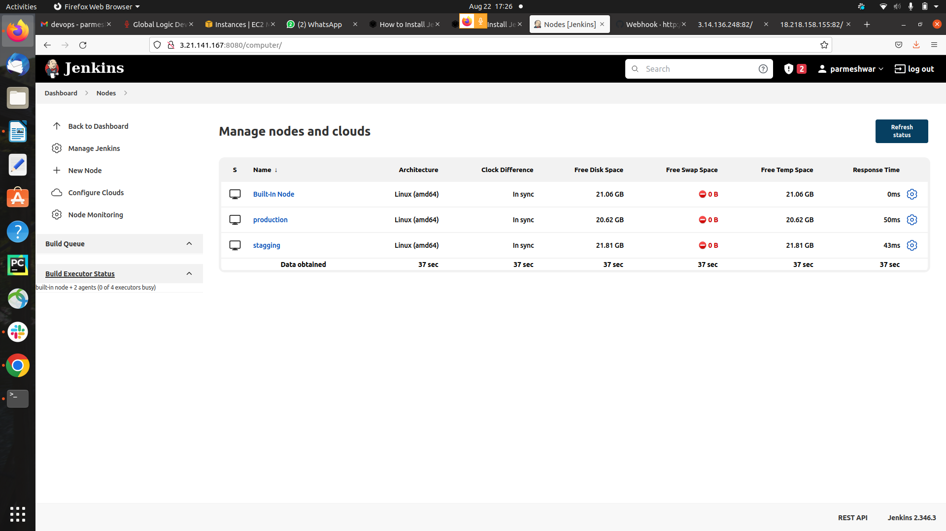

**Step 2) created the project and runs successfully**

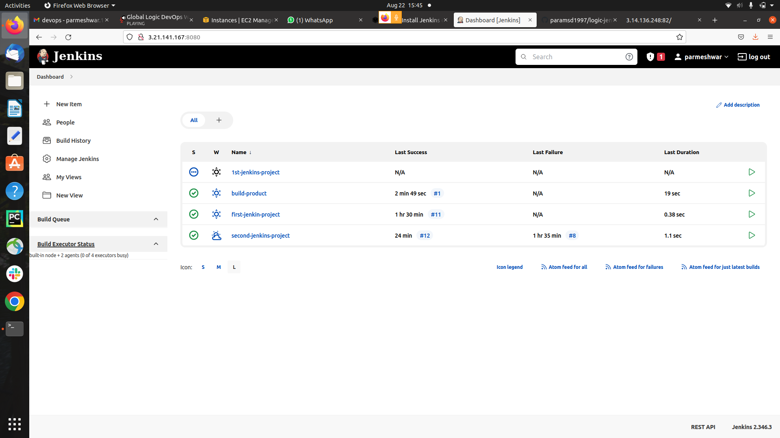

**step) Index.html page**

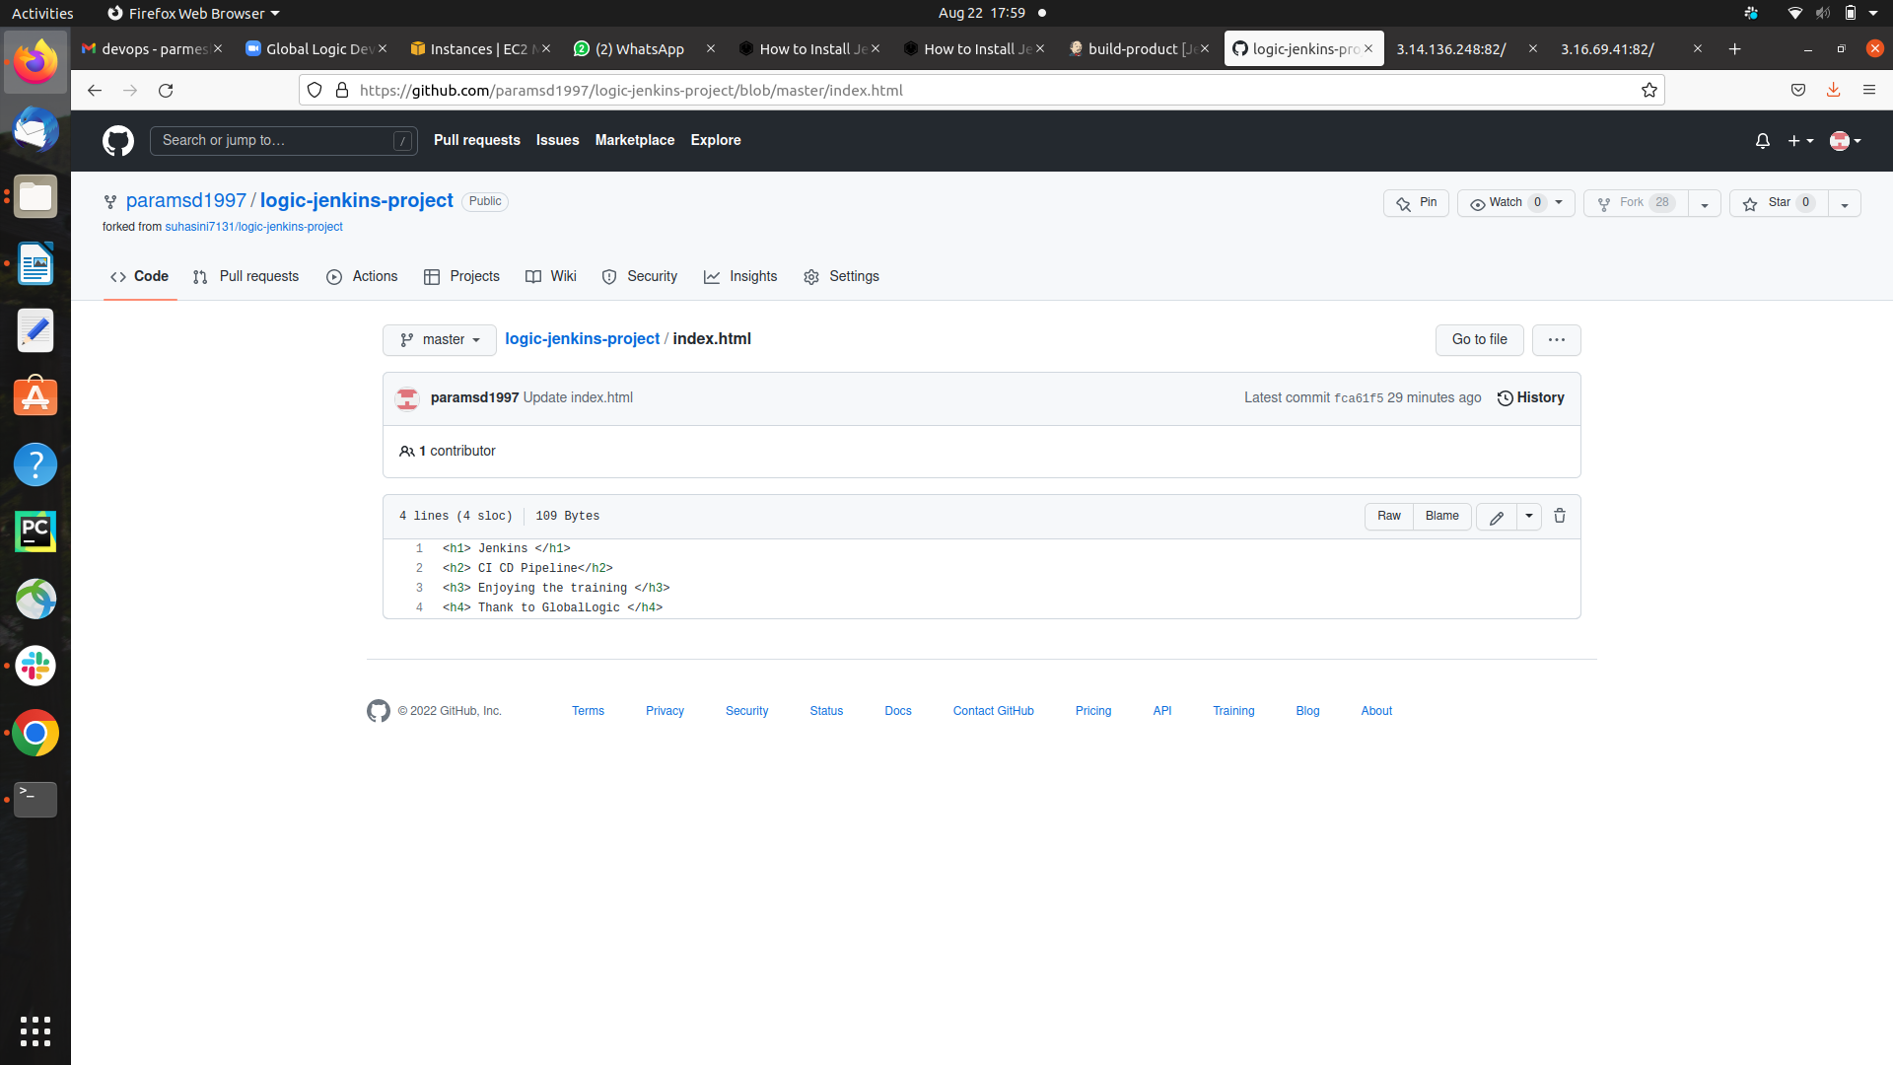

**step3)public ip of the Stagging node**

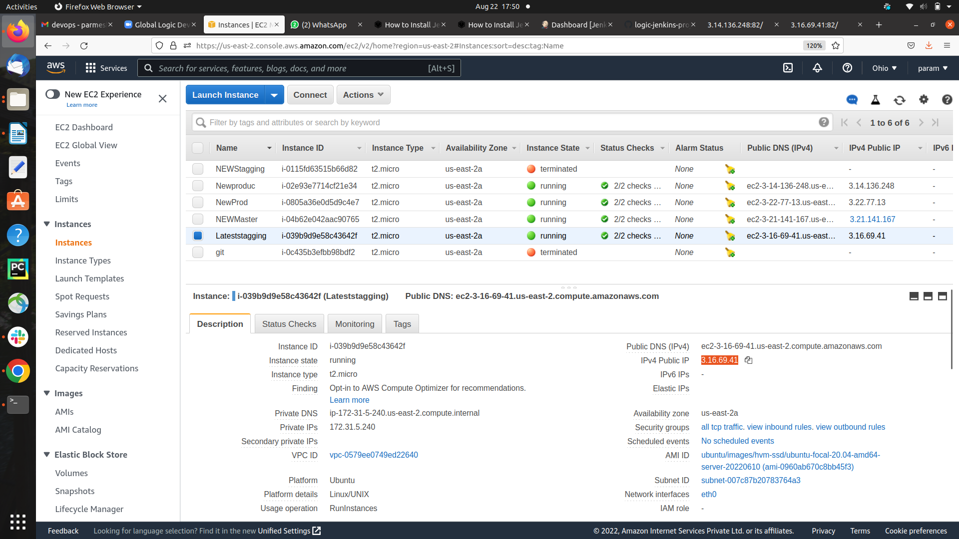

**ouput – Accessing the output with public ip of stagging node**

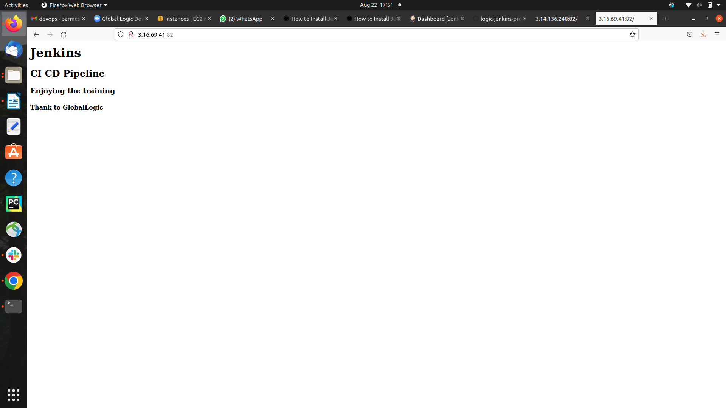

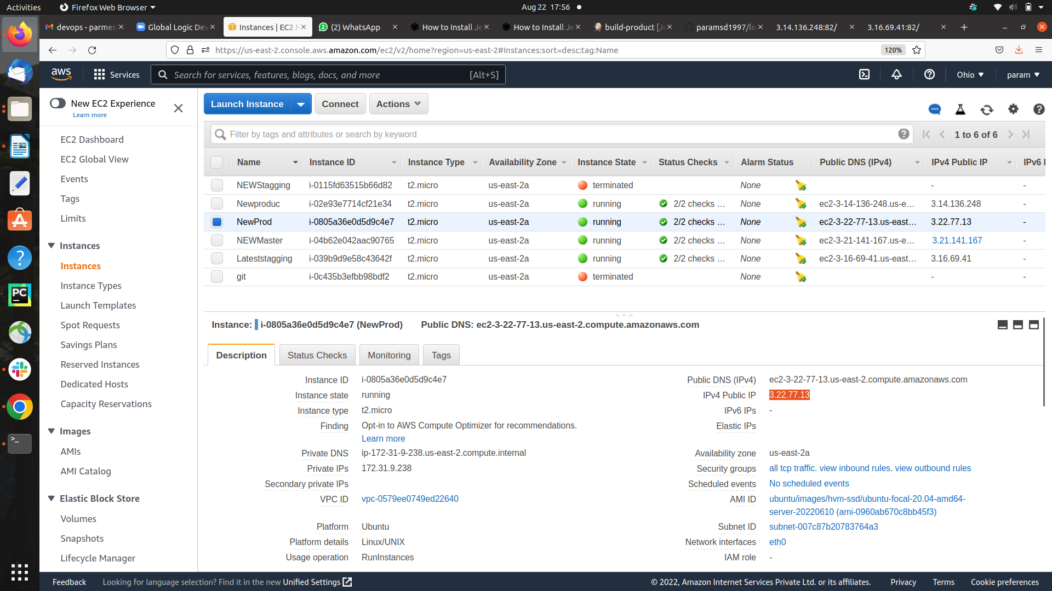**step4) public ip of the production node**

**ouput – accessing the output with public ip of production node**

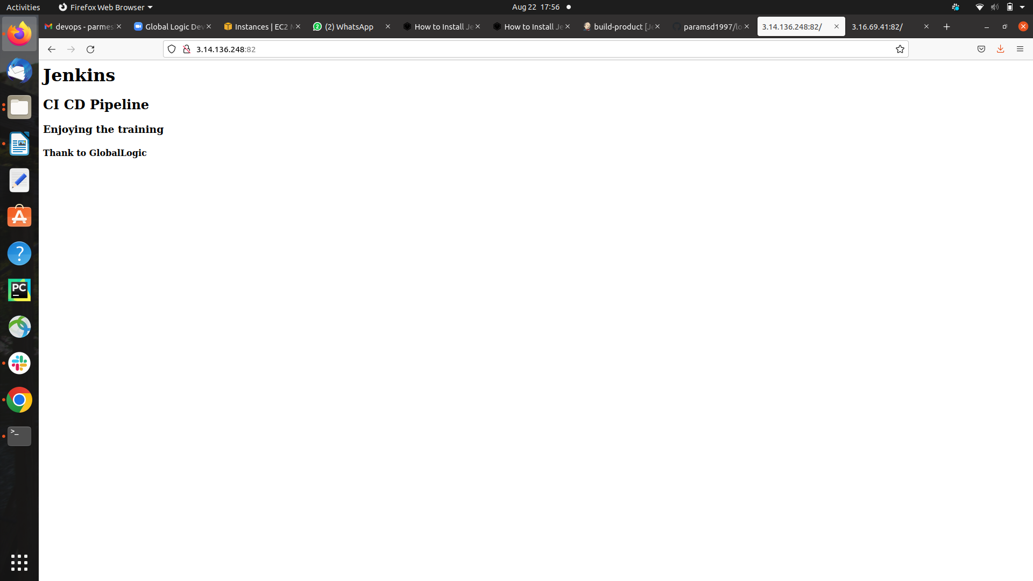

**step 4) pipeline setted successfully**

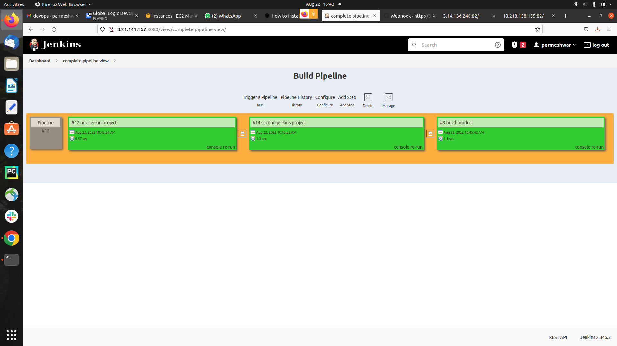

**step 6) setted the pipeline parallely**

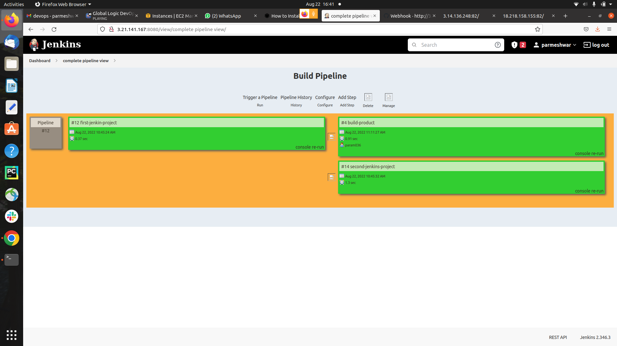

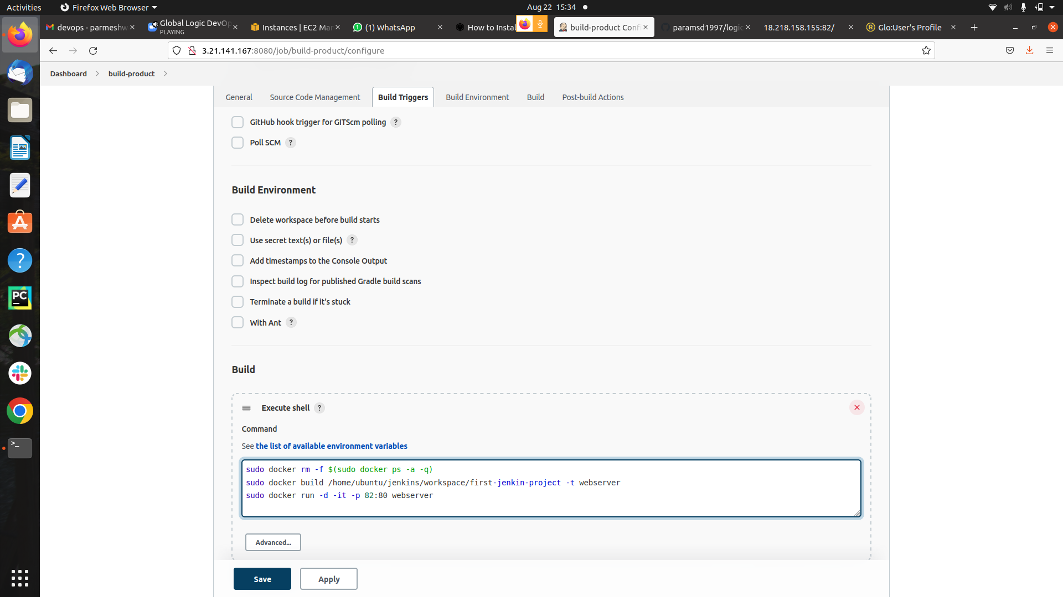**shell scripting**